Improving CMRR in CAT-5 video links and other differential video transmitter-receiver applications
By Maithil Pachchigar<br>Applications Engineer,<br>National Semiconductor
Video Imaging DesignLine
A 26, 2007 (4:15 H)
URL: http://www.planetanalog.com/showArticle?articleID=202800075
Operational amplifiers are extensively utilized in real-world video transmission applications where common-mode signals play an important role. One such application is in differential video transmitters-receivers over a CAT-5 cable. When dealing with differential signals, it is always essential to extract weak signals in the presence of unwanted common mode signals such as noise, hum, or DC-offset voltages. Even though op amps have some common-mode rejection, there is still some of the common-mode (V_{CM}) signal that transfers into the output at unity gain. Therefore, choosing the appropriate voltages for V_{CM} is an important design consideration. Designers may sometimes overlook the requirement of limiting the total common-mode voltage plus the signal voltage, to prevent the amplifier's internal input stage from saturating. This may especially be of concern for lower supply voltage applications. The following design idea illustrates how to improve the common-mode rejection ratio in single supply differential video transmitter-receivers over a CAT-5 cable.
Schematic description
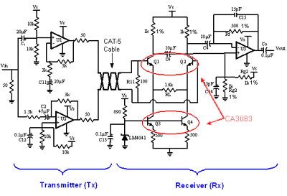
View full size
Figure 1: Single Supply Tx-Rx Schematic
This design consists of a differential transmitter (Tx), incorporating the differential transmission's inherent noise rejection advantage, and a two stage differential receiver (Rx) which improves CMRR, compared to an integrated single stage, in order to boost the SNR at the output. A single supply voltage feedback op amp, such as National Semiconductor's LMH6643, is used to implement the design. As shown in Figure 1, the Tx consists of two op amps, U1 and U2, (both LMH6643s) operating under a single supply of +8V. U1 and U2 are operated in non-inverting and inverting configurations with gains of +2 and -2, respectively. Both U1 and U2 have similar noise gain and therefore provide matched output bandwidths, which is important in maintaining balance. The input signal is AC-coupled to the Tx inputs through input coupling capacitors C1 and C2 with U1 and U2 biased to half of the supply voltage (4V in this case).
The values of C1 and C2 are selected to set the lower cut-off frequencies of op amps, U1 and U2, at f_{C1}=1/(2*∏*5k ohm*20µF) = 1.59Hz and f_{C2}=1/(2*∏*1.5k ohm*47µF) =2.25Hz, respectively. This is in order to allow the lower video frequency harmonics to pass through. Series 50ohm resistors at the output of U1 and U2 provide impedance matching to the CAT-5 transmission line which has a characteristic impedance of about 100ohms. The output of the Tx is terminated with the 100ohm resistor (R11) at the Rx front-end to provide cable back termination.
The Rx consists of the differential transistor pair Q1 and Q2, current source transistor pair Q3 and Q4, and the LMH6643 difference amplifier, U3. The current source transistors Q3 and Q4 are biased from a fixed reference voltage of 1.2V, which is supplied by National Semiconductor's LM4041 Voltage Reference. The outputs from the collectors of Q1 and Q2 are AC-coupled to U3. U3 is then biased to about 4V, which also sets the output bias voltage to mid-supply. Capacitor values for C₁₄ and C₁₅ were selected for a cutoff frequency of 21.2 MHz (f = 1/(2*∏*500ohms*15pF)) in order to reduce excessive peaking in the output frequency response. The output of U3 is then finally AC-coupled to subsequent stages in the video signal path, or alternatively, to a 75ohm video load.
Next: Theory of circuit operation
Theory of circuit operation
In Figure 1, the 1V_{P-P} input signal to the Tx is biased with a 4V DC offset. The Tx then amplifies the signal by a gain of 2V/V and transmits it through a CAT-5 cable. At the Rx front-end, the 2V_{P-P} signal with the 4V DC-offset appears differentially at the bases of Q1 and Q2. The current source transistors (Q3 and Q4) provide 1 mA of emitter currents (V_{E} = V_{B} " V_{BE} = 1.2 - 0.7 = 0.5V → I_{E} = V_{E} / R_{E} = 0.5V/500ohms = 1mA). These emitter currents produce the voltage across load resistor, RL, which then result in the differential collector currents that set the gain of the Rx to be +1.4V/V at the output (Vout node) in Figure 1.
View full size
Figure 1: Single Supply Tx-Rx Schematic (repeated for clarity)
To determine the total CMRR value of Tx-Rx, the common-mode gain at the output of the U3 must also be measured. This is done in the circuit shown in Figure 1 by tying the bases of Q1 and Q2 together and driving it with a 1V_{P-P} signal (including the 4V DC offset voltage) from a single output of Tx.
CMRR = 20*Log₁₀ (A_{DM}/A_{CM})
Where, A_{DM} = Differential Gain and A-_{CM} = Common-Mode Gain
A_{DM} and A_{CM} are measured using the test setups as discussed before.
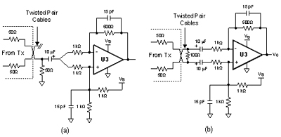
View full size
Figure 2: Single Supply Tx-U3 CMRR Measurement Schematics: (a): Common-Mode Gain Test Setup, (b): Differential Gain Test Setup
Similarly, Figure 2 shows the test setups for measuring the common-mode gain and differential gain when only U3 is used in the Rx. Accordingly, the CMRR for this case has been measured for comparison and is shown in Figure 3.
Next: Performance measurement results
Performance measurement results
In Figure 3, measured results with the LMH6643 show a CMRR of approximately 78 dB at 1 MHz and more than 100 dB at lower frequencies (less than10 KHz) for the entire Tx-Rx circuit.
The measured CMRR when only Tx-U3 is used is about 35dB less than the CMRR of the Tx-Rx at lower frequencies (less than or equal to100 KHz).
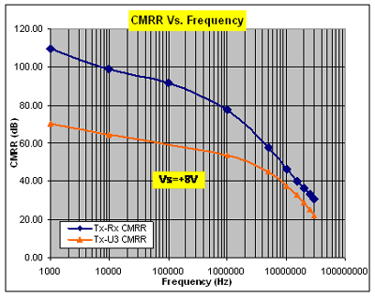
Figure 3: CMRR Vs. Frequency Plot of Tx-Rx and Tx-U3
Figure 4 illustrates a comparison of the output frequency response for the entire Tx-Rx circuit versus when only U3 is used in the receiver. The -3dB bandwidth of the entire Tx-Rx circuit is about 27 MHz, which is slightly higher than that of just U3 alone. This is well within the requirements of most composite NTSC/PAL video applications.
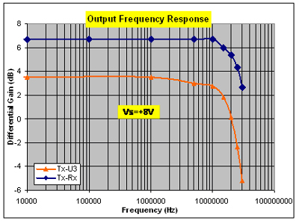
Figure 4: Output Frequency Response Comparison
Next: Impedances, matched transistors
The compound receiver's high impedance inputs provide suitable interfacing with finite source impedances and improved CMRR relative to the use of a difference amplifier alone. The receiver's high CMRR minimizes the effects of high frequency noise pickup over a long CAT-5 cable. Also keep in mind that implementing proper board layout techniques, such as minimizing trace lengths, will always play an important role in improving performance parameters such as CMRR.
For components, Rf1, Rg1, and Rg2, in particular, it is recommended that they be chosen to have relatively low tolerances. In Figure 1, resistors with a 1 percent tolerance were used. Since the difference in the ß of transistors may also affect the overall CMRR, matched transistor pairs are recommended.
View full size
Figure 1: Single Supply Tx-Rx Schematic (repeated for clarity)
In summary, this design demonstrates a low cost, minimal component solution for transmitting and receiving differential signals over a CAT-5 cable with a technique to improve CMRR in single supply video applications.
About the author
Maithil Pachchigar is an Applications Engineer in National Semiconductor's Amplifier group. He has been working extensively on high-speed and precision amplifiers. He received a master's degree in electrical engineering from San Jose State University in California and a bachelor of engineering degree in electronics from Sardar Vallabhbhai National Institute Of Technology (SVNIT) in India. He can be reached at Maithil.Pachchigar@nsc.com.

